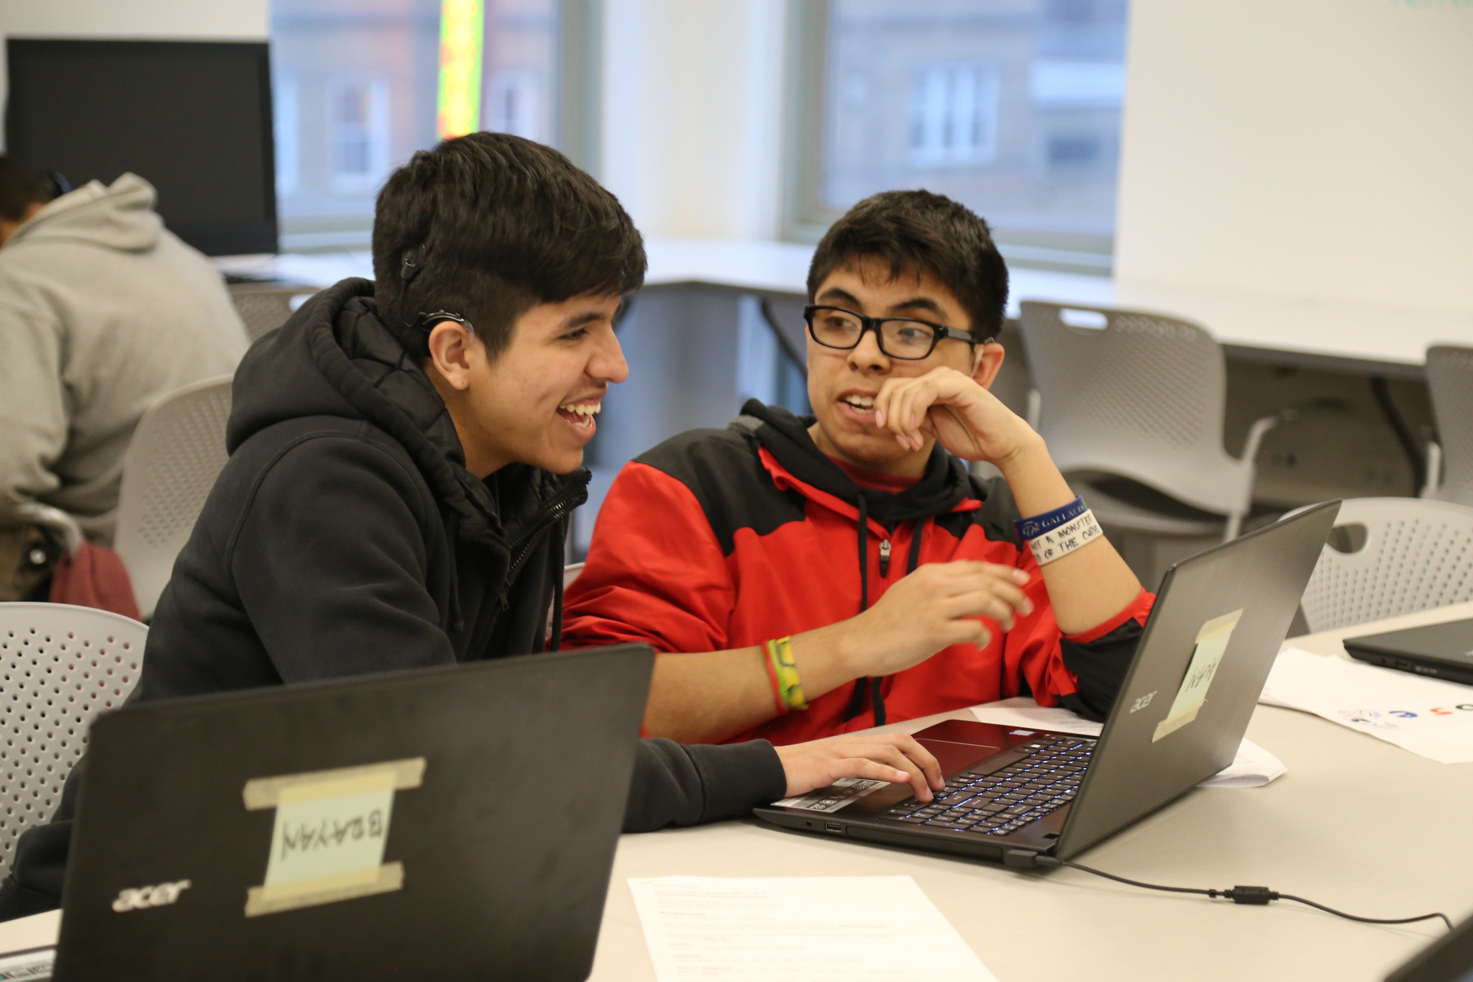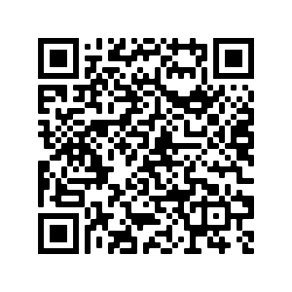

**FIND YOUR FUTURE WITH**

**AFTER SCHOOL MATTERS**

Chicago teens can discover their passion in hundreds of remote programs this fall in the arts, communications and leadership, sports, and STEM.

**Apply for Spring 2021 Programs Now! www.afterschoolmatters.org**

In these remote programs you will...

* Learn valuable skills from home.
* Work with an expert instructor.
* Engage with other teens and work on projects remotely.
* Receive a stipend.